**1 INTODUCTION**

* 1. Overview

The front cover is the first of the physical parts of book. It has one purpose; to sell the book by intriguing the right readers. The essential elements of a front cover include title and author name. Optional elements include the subtitle (if there is one) and photos, background images or graphics.

* 1. Purpose

In a metaphorical sense, a book cover is also a frame around the text and a bridge between text and world. The cover functions simultaneously as an invitation to potential readers and as an entryway into the universe that the writer has created, whether fictional, historical, autobiographical, or otherwise.

**2 Problem Definition & Design Thinking**

**2.1 Empathy map**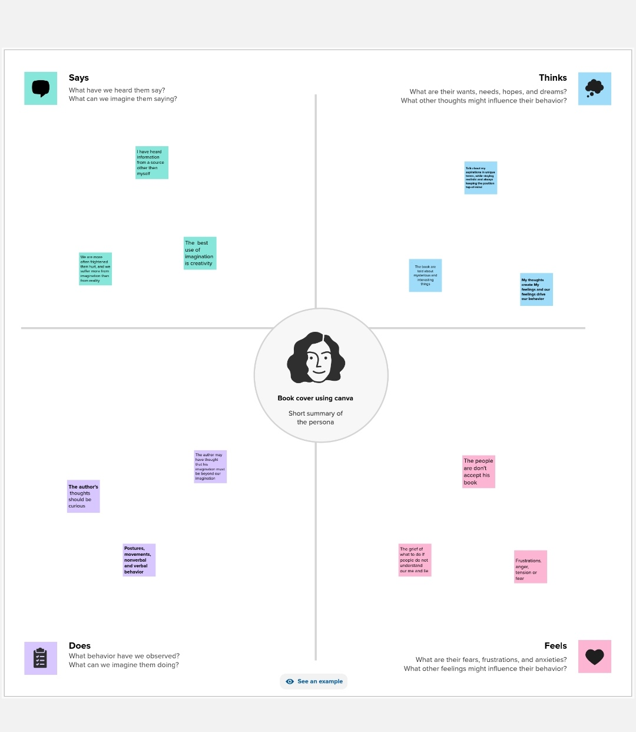

**2.2 Ideation & Brainstorming Map**

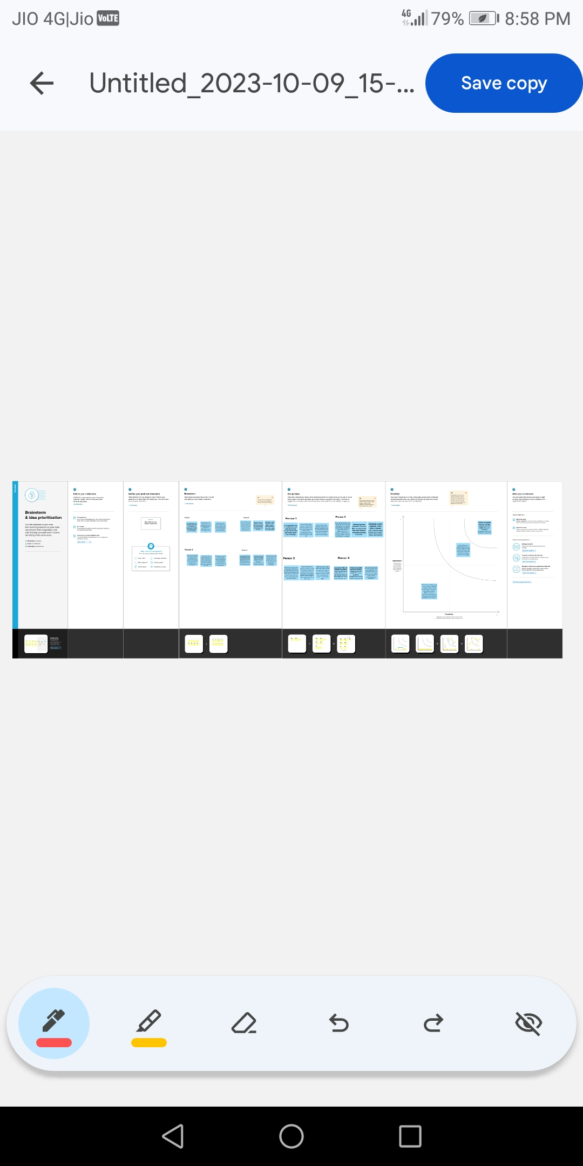

**3 RESULT**



**4 ADVANTAGES & DISADVANTAGES**

**4.1 Advantages**

Canva Offers a Variety of Templates and Elements

Templates Can be Altered to be More Custom

Canva offers a Professional Look

**4.2 Disadvantages**

Cannot Download the “Raw” File to our Computer

The Free Version is Limited

We are Unable to Move One Design to Another Design

**5 APPLICATIONS**

We have used Mural application and Canva application

**6 CONCLUTION**

We have created book cover with the help of canva

**7 FUTURE SCOPE**

We were planning to join the Grapic designing course